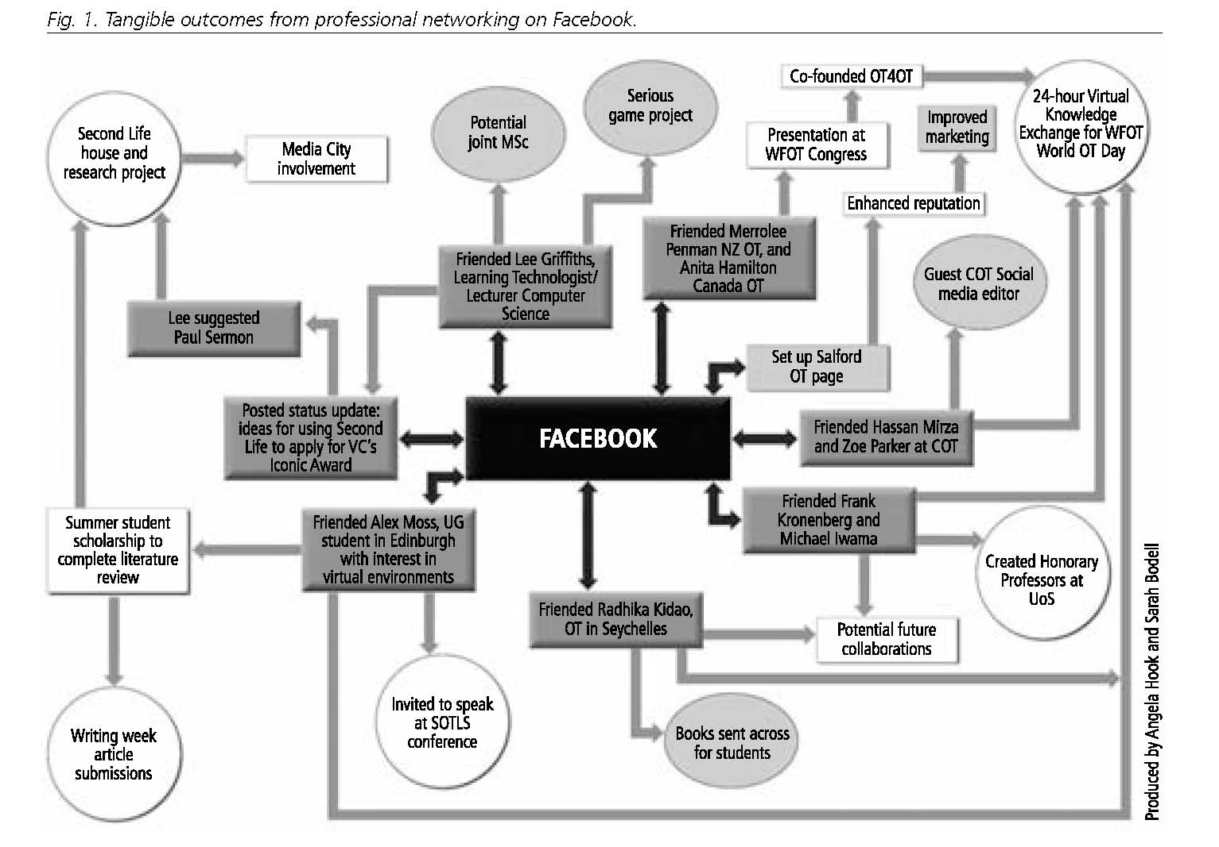

Fig. 1. Tangible outcomes from professional networking on Facebook, from: Bodell S, Hook A (2011) Using Facebook for professional networking: a modern-day essential. British Journal of Occupational Therapy, 74(12), 588-590.

Produced by kind permission of the College of Occupational Therapists who is the copyright holder.

